- The diagram below is a high level breakdown of what is currently required to sell products digitally. The process outlined in red is the major bottleneck, and is where we’d like to point your discovery.
- Note: The digital production process doesn’t get started until after print metadata is complete. This is discussed more below under SKUs, but i short: today, a digital product can’t exist without a print product existing first.

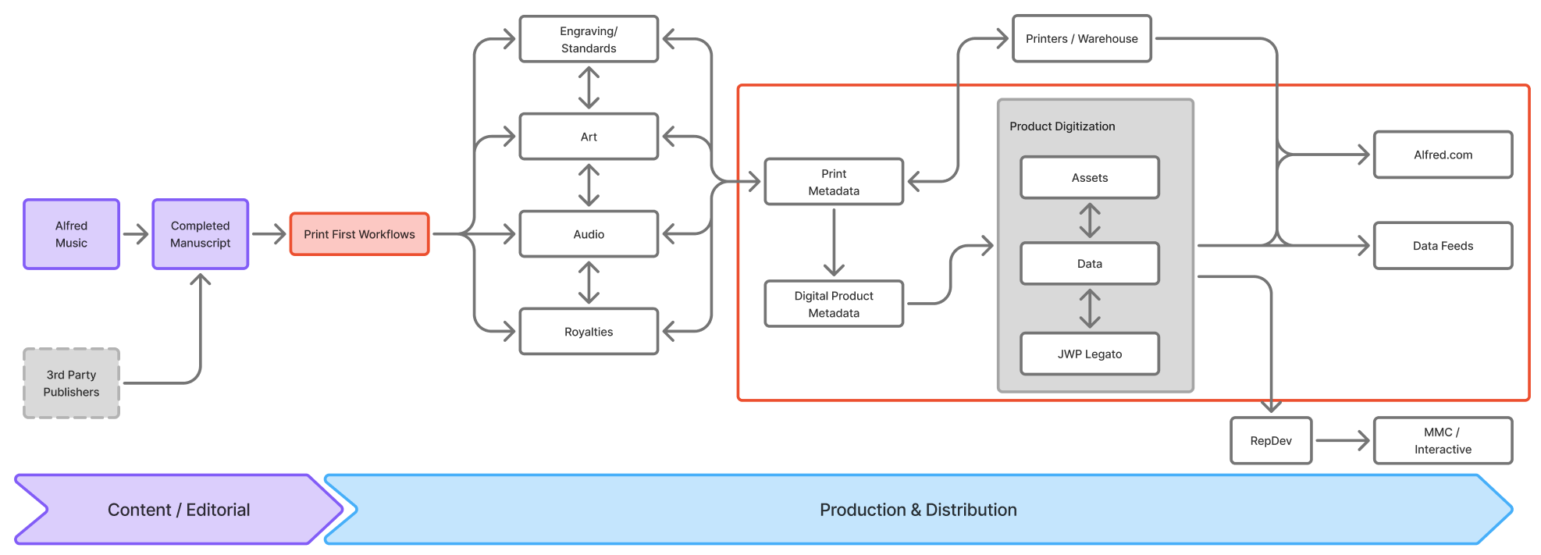

- Here is the breakdown of steps required to get through that red-highlighted section:

- Gather Data from multiple sources including WebCRD, Filemaker, PDF
    - As noted above, print metadata (and a SKU) for a product must exist first. The “source of truth” for that print metadata is a Filemaker Pro database.
- Format Into a Template (ensemble-specific)
    - These are ensemble-specific because a SKU is derived using values that indicate whether the product is a Score, a Set (Score + all Parts), or an individual Part. Similarly, a choral octavo will also be indicated by the content of the SKU value.
- Create a Digital Sku - this occurs in SQL Server and (beyond just the SKU) often duplicates the physical product metadata in Filemaker
- Get MRID (unique ID that is created for every new record in the Legato system, and is the ID value used by Legato-integrated dealers when accessing the product’s data/assets)
    - Note: Legato is a system owned by an external distributor (JW Pepper). Early in Alfred’s efforts to sell digital products, using Legato was the fastest path to making a PDF digital product available for sale. As a result, much of the current process to list and sell a digital product is based on that legacy.
- Upload the digital product metadata
  - Legato
  - AWS
  - FTP (non-Legato distributors)
- Acquire the PDF product.
- Change file name to match the digital sku that the SQL system assigns
- Upload PDF product file:
  - Legato
  - AWS (Alfred.com)
  - Archive

- A diagram of the relationship between a title, its physical SKUs, and the child/grandchild digital SKUs. As mentioned above, even a product that is only going to be delivered digitally must have a a physical SKU and metadata created for it (the “dummy” SKU):
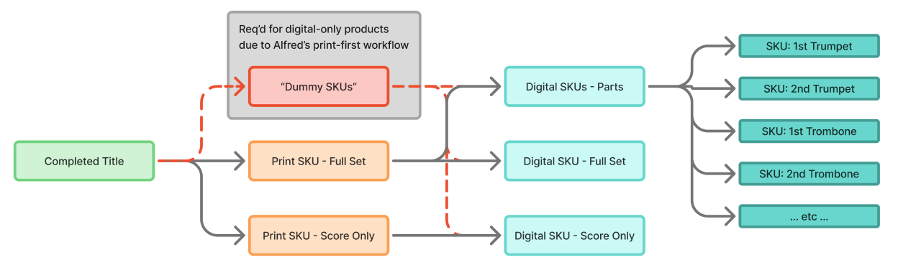

- Below is a conceptual view of where we’d like to get with our product process. Things to note:
  - The process will be the same whether the title comes from Alfred Music or a 3rd party publisher.
  - As with the current process, there are multiple teams that provide data or assets for that product - art, audio, metadata, etc.
  - We would like to see those happen in parallel with each team being a gate or checkpoint the product must go through before it’s ready to become a digital product. The Production Owner has oversight of those teams and monitors the status of titles in production.
  - Once the title is ready to be a digital product, it will live in our Content Hub (separate 2026 initiative), where it is then available for delivery to existing sales channels. It would also then be available for print delivery and/or for our internal RepDev team to process for interactivity.
    - Our long-term aspiration is to use as much print-on-demand capability as is economically feasible, with only certain Top N titles may continue to be printed for inventory.
  - SCOPE: The diagram below is included for context around the broader initiative. For this discovery, we’d like the focus to be on the process that defines the data for a product and its assets - its SKUs, metadata, and the many manual steps and duplicate-entry that are involved.
